**Requirements for Seal**

One Copy in folder to Grade

Everything must be **TYPED**

**Copy Emailed** to Teacher

***COVER Page:***

**Service Verification Forms *4 TOTAL (20 hours)***

**Power Point *(10 slides minimum)***

**Presentation AFTER SCHOOL to Committee**

***Presentation* RUBRIC**

**Reflection Write Up: (1-2 pages typed)**

***Reflection Write Up Grading* RUBRIC**

***Student Worksheet:* RUBRIC**

***COVER Page:***

**Name**:

*Student ID Number*:

**Title of Service Project:**

*(Group Members Names*)

**US Government and Economics**  Period Number:

Teacher Name

**Service Verification Forms: 4 in TOTAL *(20 hours)***

Answers complete sentences minimum paragraph for each question:

**ONE for Each Phase:**

**Planning: 3 hours**

**Research: 3 hours**

**Service Activity Action: 8-10 hours**

**Planning Power Point and Presentation: 6 hours**

Community Issue Addressed   
*What was problem or issue that you saw in the community?*  
*Why do you believe the problem exist?*   
*Why do you feel that there is there a need for the service?*  
*What was your plan to help community and how did you carry out the plan?*

Brief Description of Learning and Planning:

*Date(s) of Activity/Work:*Name of Group, Organization or Agency: *(Where you did your service)*

Brief Description Community Service Activity:  
Date(s) of Activity/Work   
*Total Number Service Hours:*

*At end of service project concluded, complete following:*

*I certify that student named has completed all hours documented.*

*Supervisor Name: (Printed)*  
*Title of Supervisor:*

*Name of Group, Organization or Agency:*  *Supervisor Signature: (Signed):  
Phone/Email:   
Date:*

**Power Point: (10 slides minimum)**

***2 slides a page and double sided printed (digital copy sent)***

**Presentation: (8 to 10 Minutes) *Script***

**AFTER SCHOOL to Committee: *Presentation RUBRIC***

**Reflection: Write Up (1-2 pages) Typed**

***Grading RUBRIC***

***Student Rubric Worksheet***

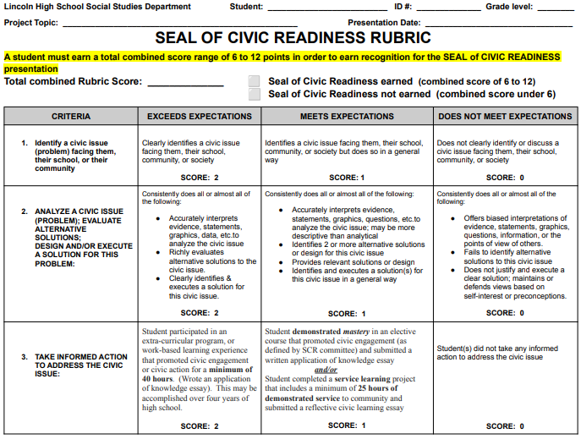

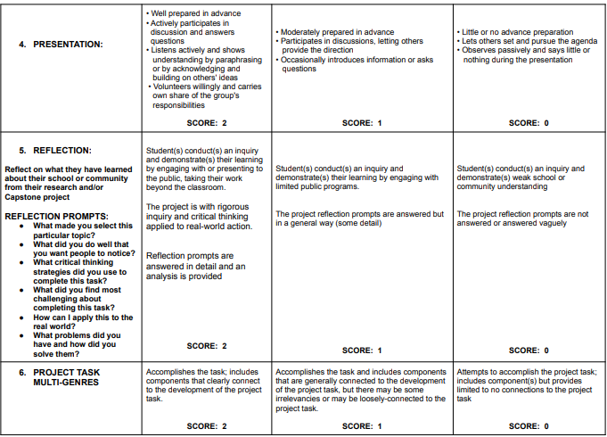

**PRESENTATION. *(8-10 minutes)***



